ISNI SRU Search API: Guidelines and Examples

Introduction

In November 2011, the International ISNI Agency (ISNI-IA) database was made publically available. The database currently includes a million identities with assigned ISNI status together with rich metadata comprising names, name variants, script and transliteration variants and pseudonyms along with associated works, institutions, colleagues and other distinguishing data. It includes creators in all classes and roles; authors, composers, performers, editors and researchers.

The ISNI-IA is encouraging widespread diffusion and adoption of ISNIs. To this end, the core metadata is freely available for enquiry from its web site (http://www.isni.org) and via the search API, using SRU.

The API is using the SRU standard, version 1.1.

Free access

The base URL for this service is:

http://isni.oclc.nl/sru/DB=1.2/

If you enter the URL without a subsequent parameter, the SRU explain record is returned. This record is rendered in the browser with a style-sheet showing the options for searching and record formats to return

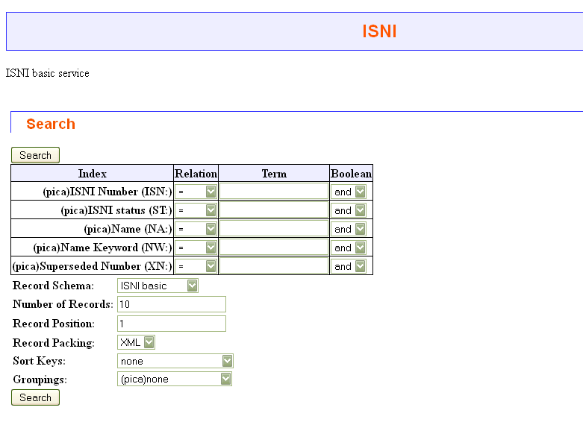
There are two main ways to search, by ISNI or by name keyword.

Example search by name keyword (pica.nw):

http://isni.oclc.nl/sru/?query=pica.nw+%3D+%22maloy%2Brebecca%22&operation=searchRetrieve&recordSchema=isni-b

This search is for the any records containing both “Rebecca” and “Maloy” in the name

Example search by ISNI:

http://isni.oclc.nl/sru/?query=pica.isn+%3D+%220000000115677274%22&operation=searchRetrieve&recordSchema=isni-b

It is also possible to search by exact name in the format “surname, forename”: example:

http://isni.oclc.nl/sru/?query=pica.na+%3D+%22maloy%2C+rebecca%22&operation=searchRetrieve&recordSchema=isni-b

This search is a more precise search for the author “Maloy, Rebecca”.

Records are returned in the ISNI XML enquiry schema (ISNI enquiry response.xsd). Further schemas will be supported, including RDF.

This is the response for the search above:

<srw:recordData>
<responseRecord>
<ISNIAssigned>
<isniUnformatted>0000000115677274</isniUnformatted>
<isniURI>http://isni.org/isni/0000000115677274</isniURI>
<ISNIMetadata>
<identity>
<personOrFiction>
<personalName>
<nameUse>public</nameUse>
<surname>Maloy</surname>
<forename>Rebecca Ann</forename>
<source>PROQ</source>
</personalName>
<personalName>
<nameUse>public</nameUse>
<surname>Maloy</surname>
<forename>Rebecca Ann</forename>
<source>AMS</source>
</personalName>
<personalName>
<nameUse>public</nameUse>
<surname>Maloy</surname>
<forename>Rebecca Ann</forename>
<source>VIAF</source><source>NUKAT</source>
</personalName>
<personalName>
<nameUse>public</nameUse>
<surname>Maloy</surname>
<forename>Rebecca Ann</forename>
<source>VIAF</source><source>LC</source>
</personalName>
<personalName>
<nameUse>public</nameUse>
<surname>Maloy</surname>
<forename>Rebecca Ann</forename>
<source>VIAF</source><source>BAV</source>
</personalName>
<creativeActivity>
<creationRole source="PROQ">AUT</creationRole>
<creationRole source="AMS">"aut"</creationRole>
<creationRole source="VIAF">aui</creationRole>
<creationClass source="AMS">"text"</creationClass>
<creationClass source="VIAF">am</creationClass>
<creationClass source="VIAF">am</creationClass>
<creationClass source="VIAF">dm</creationClass>
<titleOfWork source="VIAF">
<title>@München, Bayerische Staatsbibliothek, Clm
14965b</title>
</titleOfWork>
<titleOfWork source="VIAF">
<title>@München, Bayerische Staatsbibliothek, Clm
14965b</title>
</titleOfWork>
<titleOfWork source="VIAF">
<title>@München, Bayerische Staatsbibliothek, Clm
14965b</title>
</titleOfWork>
<titleOfWork source="VIAF">
<title>@Tonary of Frutolf of Michelsberg</title>
</titleOfWork>
<titleOfWork source="VIAF">
<title>@Tonary of Frutolf of Michelsberg</title>
</titleOfWork>
<titleOfWork source="VIAF">
<title>@Inside the offertory</title>
</titleOfWork>
<titleOfWork source="VIAF">
<title>@Inside the offertory</title>
</titleOfWork>
<titleOfWork source="VIAF">
<title>the @offertory chant</title>
</titleOfWork>
<titleOfWork source="VIAF">
<title>@inside the offertory</title></titleOfWork>
<titleOfWork source="VIAF">
<title>@München, Bayerische Staatsbibliothek, Clm
14965b the tonary of Frutolf of Michelsberg [ff.34-73v]
</title></titleOfWork>
<identifier>
<identifierType>ISBN</identifierType>
<identifierValue>9781896926759</identifierValue>
<source>VIAF</source></identifier>
<identifier>
<identifierType>ISBN</identifierType>
<identifierValue>9781896926759</identifierValue>
<source>VIAF</source></identifier>
<identifier>
<identifierType>ISBN</identifierType>
<identifierValue>9781896926759</identifierValue>
<source>VIAF</source></identifier>
<identifier>
<identifierType>ISBN</identifierType>
<identifierValue>9780195315172</identifierValue>
<source>VIAF</source></identifier>
<identifier>
<identifierType>ISBN</identifierType>
<identifierValue>9780195315172</identifierValue>
<source>VIAF</source></identifier>
</creativeActivity>
</personOrFiction>
</identity>
<sources>
<codeOfSource>VIAF</codeOfSource>
<sourceIdentifier>39671569</sourceIdentifier>
<reference>
<class>ALL</class>
<role>CRE</role>
<URL>http://viaf.org/viaf/39671569</URL>
</reference>
</sources>
<sources>
<codeOfSource>AMS</codeOfSource>
<sourceIdentifier>1970.00</sourceIdentifier>
</sources>
<sources>
<codeOfSource>PROQ</codeOfSource>
<sourceIdentifier>3014326</sourceIdentifier>
</sources>
</ISNIMetadata>
</ISNIAssigned>
</responseRecord>
</srw:recordData>

Version | Date | Comment
1 | 2011-12-16
2 | 2012-07-31 | Updated XML example

